**CS3600 - LAB 0 (20 points) Due February 2nd Tuesday**

**Name:______Daniel Martinez________**

**#900: ______940137_________**

Step1 [For Windows users]

Download VirtualBox from the below link.

<https://www.virtualbox.org/wiki/Downloads>

Step 2

Install Ubuntu GNOME in VirtualBox

Install **gcc** using below command

$ sudo apt update

Check for the compiler

$ gcc- version

Step 3

**Part 1:** Give the output/function of the below given commands (Use CLI)

1. $ echo CS3600 Lab 0

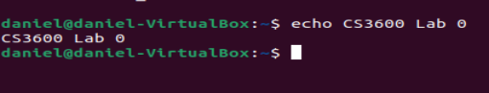

1. $ pwd



1. $ date



1. $dir



1. $ls



1. $mkdir test

Creates “test”in directory

1. $ls

ls lists files, specifically differently formatting of the files in a more normal way compared to Dir

1. $date >> mytest

Doesn’t show output but does create a file “mytest” with the date inside

1. $ cat mytest

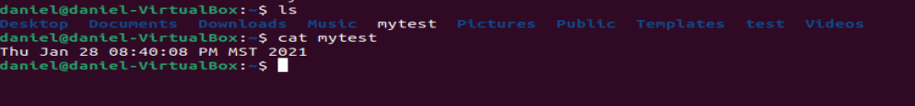

1. $ rm mytest

deletes the file



**Part 2 :** Write the command for the following output/function

1. Display the full path of your home directory.

$ pwd

1. Go to your home directory.

$ c or c~

1. List all the files in your current directory.

$ ls

1. Now, create a new folder called ‘temp’.

$ mkdir temp

1. Rename this folder to ‘files’.

$ mv temp files

1. Go to the ‘files’ folder.

$ cd files

1. Run a command to get the current date and time and save the output to a file called 'nw'

$ date >> nw

1. Copy ‘nw’ to a file called 'before'

$ cp nw before

1. List all the files in this directory. Use a more detailed listing where you can see the files' permissions, date written, etc.

$ ls -l

1. Create a file called 'temp'

$ touch temp

1. Rename 'temp' to 'test'

$ mv temp test

1. Go up one directory.

$ cd..

1. Delete the ‘files’ folder with a single command. (The command you use should also delete all of the files inside of the folder.)

$ rm -r before

**Part 3:** Write the command for the following output/function

1. Create a file called 'secret' containing the text “It's a secret!” using the echo command.

$ echo “It’s a secret!” >> secret

1. Change the permission of this file in such a way so that no one can write to it. Use the ls command to show the file name and permissions. (use chmod command)

$ chmod -w secret

$ ls -l secret

1. Try to add more text to 'secret' using the cat command. What is the output?

“bash: secret: Permission Denied”

1. Try to read the file using cat. What is the output?

“Secret”

**Part 4:** Add the resources used to do the lab below.

<https://help.ubuntu.com/community/UsingTheTerminal>

<https://askubuntu.com/questions/21556/how-to-create-an-empty-file-from-command-line>

<https://www.earthdatascience.org/courses/intro-to-earth-data-science/open-reproducible-science/bash/bash-commands-to-manage-directories-files/#:~:text=Delete%20a%20Directory%20(%20rm%20%2Dr,%2Dr%20directory%2Dname%20)>.

<https://stackoverflow.com/questions/17189237/how-can-i-write-and-append-using-echo-command-to-a-file>

<https://help.ubuntu.com/community/FilePermissions>

<https://askubuntu.com/questions/528411/how-do-you-view-file-permissions#:~:text=If%20you%20want%20to%20see,path%2Fto%2Ffile%20command>.